A REPORT

ON

TEXT SUMMARIZATION USING TEXT RANK ALGORITHM

AND TEXT EXTRACTION FROM IMAGE
By

Ayush Govil 1700120C202

Prepared in the partial fulfillment of the
Practice School II Course

AT

Verzeo Edutech, 9th Main Rd , Sector 7, HSR Layout, Bangalore, Karnataka 560102

A Practice School Station of


BML MUNJAL UNIVERSITY

May-June 2019

BML MUNJAL UNIVERSITY
PRACTICE SCHOOL II JOINING REPORT
Date: 22/05/2019

Name of the Student | AYUSH GOVIL
Name and Address of the Practice School – II Station | #675, 3rd Floor, 9th Main Rd, Opposite HDFC bank, Sector 7, HSR Layout, Bangalore, Karnataka 560102
Location of the Project | Bangalore, Karnataka
Name and Designation of the Industry Guide/ Industry Mentor for the Project | Mr.Anmol Agarwal  Machine Learning Engineer
Industry Mentor Contact No. | +91-6362608913

Acknowledgement

The internship opportunity I had with Verzeo Edutech was a great chance for learning and professional development. Therefore, I consider myself as a very lucky individual as was provided with an opportunity to be a part of it. I am also grateful for having a chance to meet so many wonderful people and professionals who lead me through this internship period Bearing in mind previous I am using this opportunity to express my deepest gratitude and special thanks to the Mr. Anubhav Agarwal, Machine learning engineer who in spite of being extraordinary busy with his duties, took time out to hear, guide and keep me on the correct path and allowing me to carry out my project at their esteemed organization and extending during the training. It is my radiant sentiment to place on record my best regards, deepest sense of gratitude to Ms. Haritha, Assistant machine learning engineer. I perceive as this opportunity as a big milestone in my career development. I will strive to use gained skills and knowledge in the best possible way and I will continue to work on their improvement in order to attain desired career objectives. Hope to continue cooperation with all of you in the future.

TABLE OF CONTENTS
CONTENTS PAGE NO.
1. INTRODUCTION 5-7
1.1 Text summarization 5-6
1.2 Text extraction from image 6-7
2. COMPANY PROFILE 8
3. PROJECT METHODOLOGY 9-20
3.1 Text Summarization Using Text Rank 9-15
3.11 Text Rank Algorithm 9-10
3.12 Extracting and Cleaning Sentences 11-13
3.13 Using Similarity matrix and PageRank Algorithm 14-15
3.2 Text Extraction from Image 16-20
4.Results & discussion 21-22
5.Conclusions and References 23

1. INTRODUCTION
1.1 TEXT SUMMARIZATION USING TEXT RANK ALGORITHM

Text summarization is a technique of extracting the most relevant information from a large amount of data so as to save time. There is a lot of information available nowadays on the internet so text summarization is used to grab the most out of the information and provide to the users. Inshorts app is one of the examples which gives a 60 words news summary. People have lost the habit from reading books, newspapers, etc due to the advancement of technology and are using it more therefore this technique is very helpful.
I have made a project on text summarization using Text rank algorithm in python.There are two techniques in Machine Learning for text summarization-
1.Extractive text summarization
2.Abstractive text summarization

I have used Extractive text summarization which finds out the top n sentences out of all the sentences in the text where n is the number of sentences you want from the text.

The library functions used are:
1.numpy-Performing high level mathematical functions on arrays
2.pandas-Data Manipulation and Analysis
3.nltk-Natural Language tool kit used for working on text
4.re-Regular Expression used for string searching and manipulation

These sentences are extracted and ranked based on the similarity with all the other sentences. The sentence which is similar to most of the sentences in the text is ranked highest. Natural Language Processing is used which is a field in machine learning that works on human language. Natural Language toolkit is a part of Natural Language Processing which is a open source library in python is used to tokenize the text into individual words. Stop words and punctuation marks are removed from the text. Each word has a vector assigned to it that is present in glove.6B.100d.txt file which has 400000 vectors. The vector for each sentence is calculated by getting the average of the vectors of each word present in the sentence. The sentences are then used in cosine similarity function which gives us the similarity value for the sentences. A similarity matrix is created for storing the cosine similarity values for each sentence present in the text. The matrix is converted into a graph where the vertices represent the sentences and edges represent the similarity values between the vertices. Finally the Page Rank Algorithm is applied on the graph and the top n sentences are extracted.

Problem Statement

There is a problem in searching relevant information from such huge data available and there is a need of summary. Text summarization helps to gives us the relevant and most meaning information by using the similarity of the sentences between all other sentences in the text. The greater the similarity, the better the information.

- Assumptions:
- The language of text is English.
- No graphs, diagrams or any visuals are present in the text.

Objectives
- Use jupyter notebook which is a open source web application that allows us to create documents that can contain code and can be used for machine learning.
- Read the csv file that contains the text using pandas module.
- Tokenize the sentence using sent_tokenize function from nltk to get sentences individually.
- Extract the vectors from glove.6B.100d.txt and store in the word embeddings dictionary where the word will be the key and vectors will be the values of each key.
- Clean the sentences by removing punctuations, special characters and stop words from the sentence.
- Get the vector values for each word in the text file from the word embeddings and calculate the average of the vectors of the words in each sentence. This average will be the vector for the sentence.
- Apply cosine similarity function between two sentences and store it in the similarity matrix.
- Convert the matrix into a graph where sentences will be the vertices and similarity values between the sentences will be edges.
- Apply Page rank algorithm on the graph and extract the top ranked sentences.

1.2 Text Extraction from image

Companies has to analyze thousands of documents like receipts, invoices, statements, contracts and get the information from the unstructured data which is tedious and time consuming sometimes manually. Text Extraction technique is useful here which can help to extract the tex
from the image where finding or recognizing text can be challenging manually. To extract the text I have used Tesseract v4 which is an OCR engine. It includes a deep learning-based model for text recognition. OCR or Optical Character Recognition involves the detection of text content on images and translation of the images to encoded text that the computer can easily understand.
The program uses 4 modules for image manipulation and text extraction-
1.opencv-Image analysis, filtration and manipulation.
2.numpy- Performing high level mathematical functions on arrays.
3.pytesseract-Extraction of text from image.
4.pil or pillow-Manipulating, opening and saving images in different formats.

For getting the most information from the image we filter the image using opencv. Image is read using opencv and stored in a variable. This image is converted from 3-D pixel value image(RGB) to 1-D or Gray Scale image. Dilation and Erosion operations are performed which removes noise and makes the image more clear for the computer. Threshold function is used to convert the image completely into black and white using a threshold value. For example: If we use a threshold value of 240 then the pixel values below 240 will be converted into 0(black) and values above 240 will be converted into white. If we use threshold inverse then values below 240 will be converted to 1 and vice-versa. By using threshold the text stands out in the image and becomes more clearly visible for the computer. This text is then extracted using the Tesseract engine. Deep learning is used while extracting the text from the image.

Problem Statement

Its very tedious for humans to extract text from complicated images therefore this project aims to solve the problem. Tesseract is helpful in extracting the text which has an in-build deep learning
algorithm that can recognize text.

Objectives

- Read the image using opencv.
- Convert the RGB image into grayscale image.
- Perform dilation and erosion operations to remove noise from the image.
- Get the image into black and white using the threshold function.
- Read the text from the black and white image using Tesseract-OCR engine.

2. VERZEO COMPANY PROFILE

Description

Operator of an artificial intelligence (AI) educational technology company intended to help bridge the gap between students' classroom environment and their workplace atmosphere. The company provides both online and offline courses while collaborating with various multinational companies (MNCs) for providing various internship opportunities, enabling students to gain real-time insights and learn from anywhere with user-friendly online training programs.

Founder- Mr Vungarala V. Subrahmanyam

Founded- 2017

Status- Private

Latest Deal Type- Series A

Latest Deal Amount- $5M

Website: www.verzeo.in

Ownership Status: Privately Held (backing)

Financing Status: Angel-Backed

Primary Industry: Educational and Training Services (B2C)

Other Industries: Educational Software
Primary Office: 839 Broadway Brooklyn New York, NY 11206 United States

3. Methodology
3.1 Text Summarization using Text Rank Algorithm
3.1.1 Pagerank algorithm
Text summarization uses Pagerank algorithm for getting extractive summary. Pagerank algorithm is used in ranking websites on the basis of links between the websites. I will give an example to show its working.

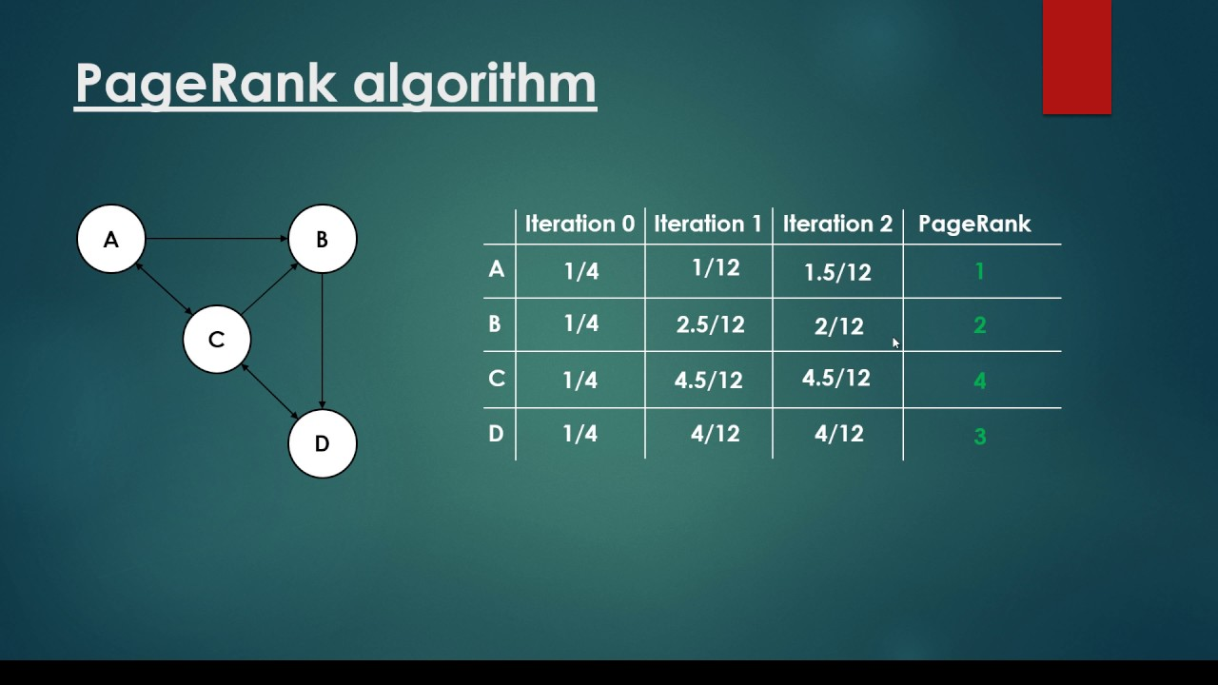

Suppose we have 4 webpages A,B,C and D. These websites are linked to each other as shown above. We will iterate through the graph from A to D and this iteration will take place for N-2 time where N is the number of vertices. We create a table to store the probability of getting access to this website of each vertex for N-2 iteration starting from iteration 0. The first iteration will be 1/Number of vertices in the graph. We get 1/4 for each vertex as the probability. General formula for getting the probability of vertices is:
.

Value of i ranges from vertex 1 to vertex 4. The vertex which points to the target vertex will be taken into consideration according to the given formula.
According to the formula we can calculate the probability of the vertices in i iterations. For example in iteration 1 we calculate the value for the first vertex A. From the graph we can see that only vertex C is pointing on vertex A.
Probability of vertex C in previous iteration i.e. i-1 iteration=1/4
Number of outgoing edges from vertex C=3

So, according to formula we get:

Probability (A1)= =>1/12

So the probability of entering website A after first iteration=1/12

Now for node B, node A and node C is pointing on it. Iteration is 1 so we take probability values from previous iteration i.e. iteration 0. Both A and C have values 1/4 so according to formula:

Probability (A0) = Probability(C0)=1/4

Probability (B1) = + => 5/24 or 2.5/12

Similarly for C and D, we repeat the procedure and get the probability of the vertices in iteration 1. Now for probability in iteration 2, we take the probability of vertices in iteration 1 which are pointing to the vertex whose probability we are calculating(target vertex). This goes on till N-2 iterations. After calculating till N-2 iterations, we rank the vertices (web pages) based on the probability we got on the last iteration of the vertices. In the table we can see that value of C is highest i:e 4.5/12 so it is ranked the highest according to the table. It means the webpage C will be shown first when we search for it on the internet. Then we get D,B and C.

This algorithm is very important for creating text summarization as it is applied to the TextRank Algorithm. The only difference is that instead of web pages we use sentences and rank them.
3.1.2 Extracting and Cleaning sentences

Before applying the page rank algorithm we first need to tokenize the text to get each word. Special characters and stopwords should also be removed from the text because they don’t giving meaning to the sentences.
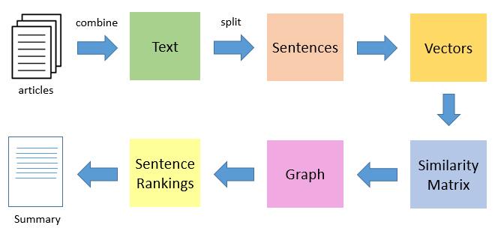

The given figure shows the steps taken to extract the summary. The first step is splitting the text into sentences. We import the modules required for the project.

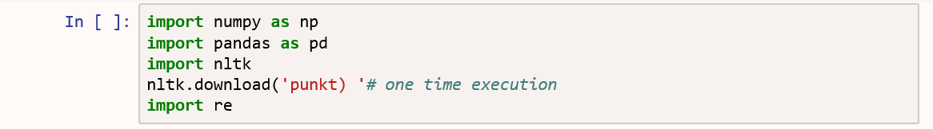

The uses of the modules are-
numpy- Array processing
pandas- Data manipulation and analysis
nltk- Tokenizing the text
re- Offers a set of functions that allows us to search a string for a match

We are also using the nltk.download ('punkt) ' function to download the punctuation model used for sent_tokenize.

Lets read the data. We use the panda function to read the csv file. CSV is a simple file format used to store tabular data. CSV stands for "comma-separated values". The syntax to read the file:

df = pd.read_csv("text.csv")

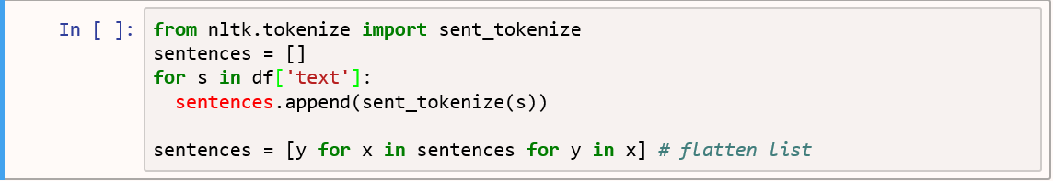

Now we tokenize the sentence to get individual sentences. I have imported the sent_tokenize module from the nltk.tokenize library. Then a sentences list is created to store the sentences.
Using for loop we store the sentences in the sentences list. The sentences.append function is used to append the sentences that we get from the sent_tokenize function. It will create a list inside a list therefore we have to flatten the list which means converting the inner list into normal data.
Download Glove word Embeddings. Glove word embeddings are vector representation of words. These word embeddings will be used to create vectors for our sentences.

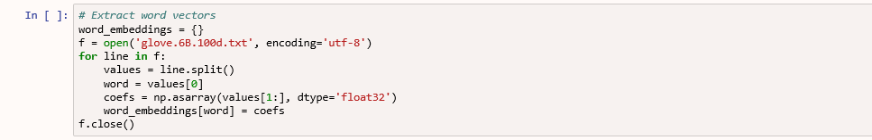

A dictionary is used to store the word vectors where word will be the key and values will be the vectors. Glove.6B.100d.txt file is used for vector representation for the words. The encoding used is utf-8 which is a 8 bit Unicode transformation format which can represent all the languages. They have bigger file size than ASCII codes. The for loop is used to traverse through the glove file. line.split function is used to split the data where “ “(space) is present. Values[0] represent the words in the glove file. After index 0, the word has vectors which are stored in the coefs array. word_embeddings[word] will store the the coefs corresponding to the word key in the dictionary.
The glove file represent vectors for 4,00,000 different words present in the dictionary.
The word_embeddings represent those vectors. You can check the length using the ‘len’ function on the word_embeddings.

length=len(word_embeddings)
print(len)

Output-400000

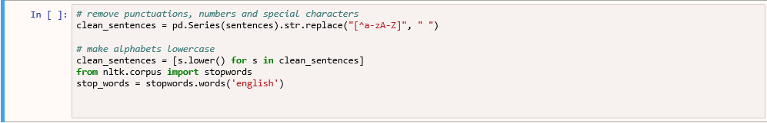

It’s important to make the text noise free. To make it noise free we have to remove punctuations and stopwords(commonly used words of a language – is, am, the, of, in, etc.) because they don’t give much meaning to the text and are ignored by the computer. If stopwords are not downloaded then we can download it using nltk.download(stopwords) function. We import the english stopwords as we are using English text.

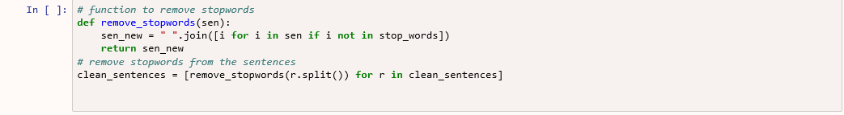
A function needs to be defined to remove the stopwords from the sentence. This function creates a new sentence that contains the text without stopwords. I have used this function to get the text without any stopwords and stored it in clean_sentences.
Finally we get the clean_sentences array which stores the sentences which is noise free(no stopwords, special characters or punctuations) and has all the sentences which is present in the text.
3.1.3 Using similarity matrix and Page Rank Algorithm

Now that we have got the clean sentences, we have to represent it using vectors and store it in a matrix.

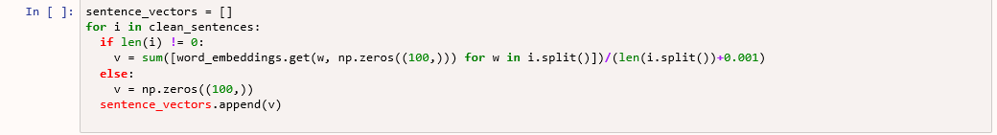

I have created an sentence vector array to store the vector representation of the sentences. The sentence vector would be represented by the average of the vectors of the words that are present in the sentences.
This average is stored in the similarity matrix that represents a graph.

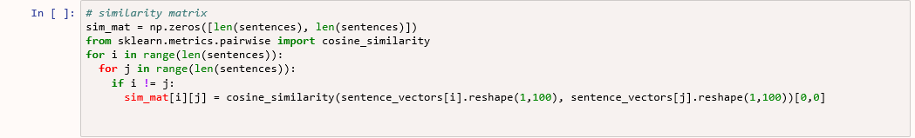

I have created a similarity matrix that has dimensions n*n with all the elements initialized as 0.
Cosine similarity function is used to find the similarity between two sentences which is stored in the matrix.
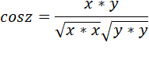
cos z represents the similarity between the two sentence by using their vectors x and y. The closer the value to 1, the more will be the similarity between the sentences. This value is then stored in the similarity matrix. The similarity matrix represents the graph where the sentences are the vertices and the edges are the similarity values between the sentences.

Finally the pagerank algorithm is applied which is the pre-defined algorithm in python.

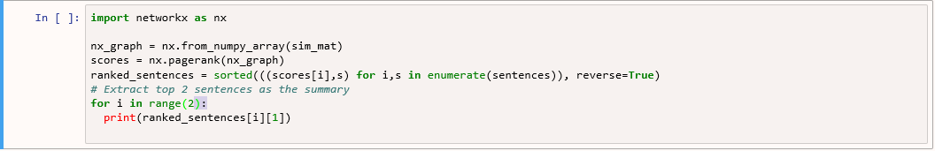

networkx library is used to convert the matrix into graph. Page rank algorithm is applied on the graph. The scores are then sorted in descending order and are stored in the ranked_sentences array. Finally I have extracted top 2 sentences based on their ranking using for loop from the ranked_sentences as summary.
3.2 Text Extraction from image

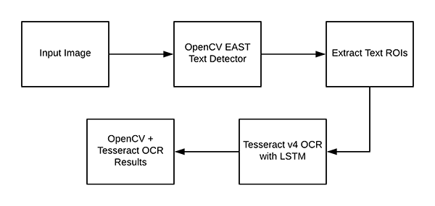

The following are the modules required for the program-

- cv2- For image recognition and manipulation
- pytesseract- For reading the text from the image
- PIL- For image manipulation
- Numpy- For creating and processing array

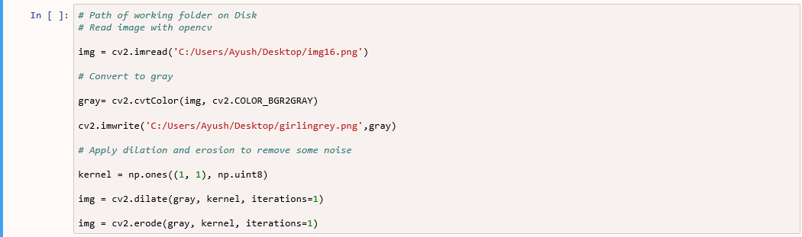



After importing the modules I have read the image file using cv2.imread function. The RGB image is converted to gray scale image which has pixels with colours between black and white.



The image is converted into grey. Dilation and Erosion (morphological operations) is applied on the image to remove the noise from the image. I have used dilation followed by erosion which is called closing. Closing is used to remove small holes or black points in the objects present in the image. This method is not noticeable in the girl image so I will show an example image-



First the dilation removes the holes by adding white pixels around and inside the letter. Then erosion is used to remove the extra pixels that are added around the letter ‘j’ and to get back the initial size.
After Dilation and Erosion the image has to be converted into black and white image so that the text stands out in the image.

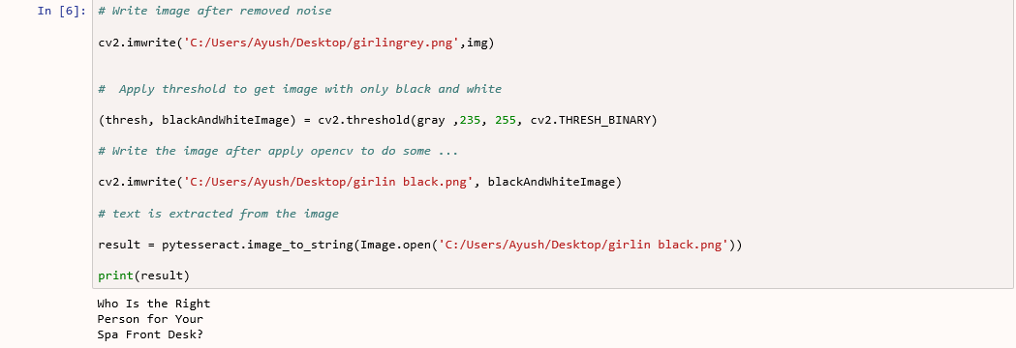

The threshold is applied to 235 which means the pixel values below 235 will be 0 i.e. converted into black and the values above 235 will become 1 i.e. converted into white.



As you can see in the image only the text part is left because the pixel value of the text in the gray image was white i.e. value above 235 while the rest of the pixel values were below 235 therefore they are all converted into black.
Now, we can use Tesseract which is an optical character recognition engine to extract the text from the image. It has a deep learning model which is used to recognize the text from the image.

Output- Who Is the Right Person for Your Spa Front Desk?
4. Results and Discussion

4.1 Text Summarization using Text Rank Algorithm
- Machine Learning plays a major role in making the text summarization algorithm.
- The top ranked sentences are extracted as summary.

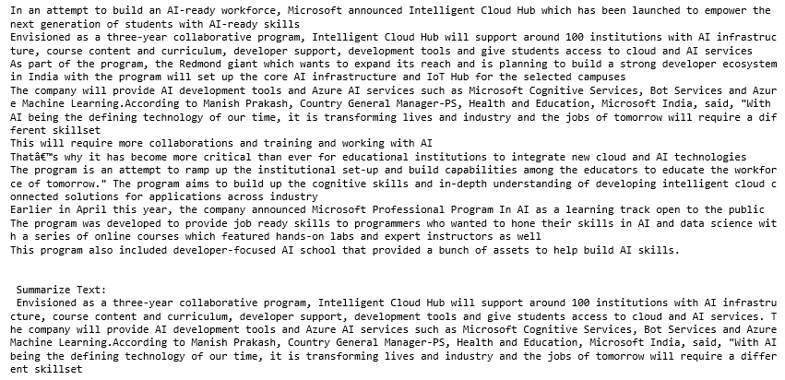

- The code has been executed in the jupyter notebook and the summarized text is obtained by extracting the top two sentences from the text. The figure shows the text used and the summarized text below it.

4.2 Text Extraction from image
- The image is converted to black and white image.
- Text is extracted from the black and white image.

Input image Output image

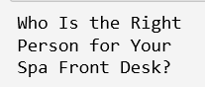

Output Text from Jupyter Notebook

- Deep Learning model is used by tesseract to extract the text from the image.
5. Conclusion

Machine Learning and Deep Learning are the subsets of artificial intelligence and many projects are based on them nowadays. They are trending fields and can completely change the way we use technology in the future. The two programs show that how useful they can be and can work just like humans in real life problems like Text Summarization and Text Extraction from image.

The increasing growth of the Internet has made a huge amount of information available. It is difficult for humans to summarize large amounts of text. Thus, there is an immense need for automatic summarization tools in this age of information overload. We emphasized on extractive text summarization which can be a better method over abstractive summarization if we want to have the exact and most relevant sentences. Python language provides all the necessary packages and libraries for making the program more simple to write and efficient.

Text locating in natural scene image with complex background is a difficult, challenging, and important problem. This job can be difficult if done manually. Many times humans can miss some text. A Deep Learning model is required that can extract text even from a complex background. Therefore filtration of the image is done and Tesseract is used which is an OCR engine that can perform the task easily and will not miss any text that is present in the image.

References

https://developer.ibm.com/tutorials/document-scanner/

https://www.analyticsvidhya.com/blog/2018/11/introduction-text-summarization-textrank-python/

https://www.techsmith.com/blog/extract-text-from-image/

International Journal of Advanced Research in Computer and Communication Engineering Vol. 5, Issue 3, March 2016 By Deepali K.

International Journal of Advanced Research in Electronics and Communication Engineering (IJARECE) Volume 4, Issue 3, March 2015 by Audumbar Misal

https://medium.com/sciforce/towards-automatic-text-summarization-extractive-methods-e8439cd54715

